Ansible Assignment

# Team members

Our team name is “Regular Space Flu”.

The following team members have worked on this assignment:

Eric Scaramuzzo

Cyril Hottiger

Riley Chetwood

Fabio Schmidberger (team leader)

# Github

The source code to our Ansible Playbook can be found here: <https://github.com/FabioSchmidberger/se_172_enterprise_software_assignments>

# Deploy

To run the deploy play you must execute the following command:

sudo ansible-playbook -i hosts.conf hello-world-webserver.yml --tags "undeploy"

The host list assumes that you want to deploy to localhost.

The play will install nginx, replace the nginx configuration file and move the index.html to the folder of statically served contend. At the end nginx will be restarted.

The following screenshot shows the execution of the deploy play.

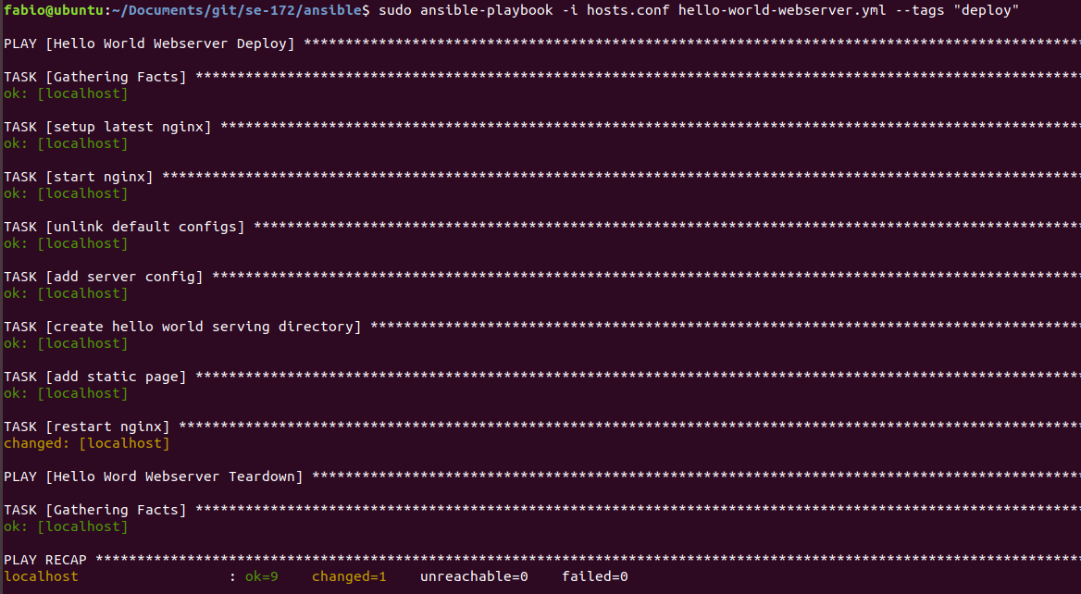

After the deploy play has been executed the deployed hello world page can be accessed on port 80.

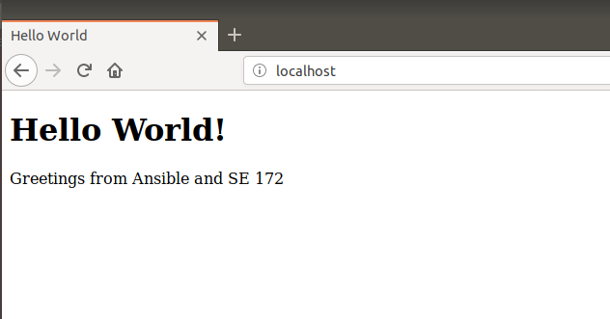

# Teardown

To run the deploy play you must execute the following command:

sudo ansible-playbook -i hosts.conf hello-world-webserver.yml --tags "undeploy"

This will stop the nginx, delete the server config and html file and uninstall nginx from the host.

